Chapter 3 Smith Exercises and Labs

1. Number Doubling program

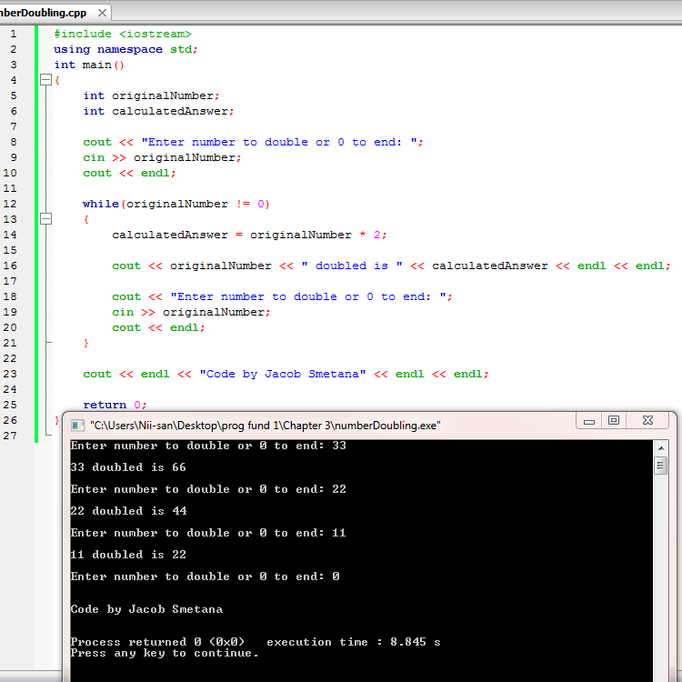

2. Lab 3-1 Flowchart

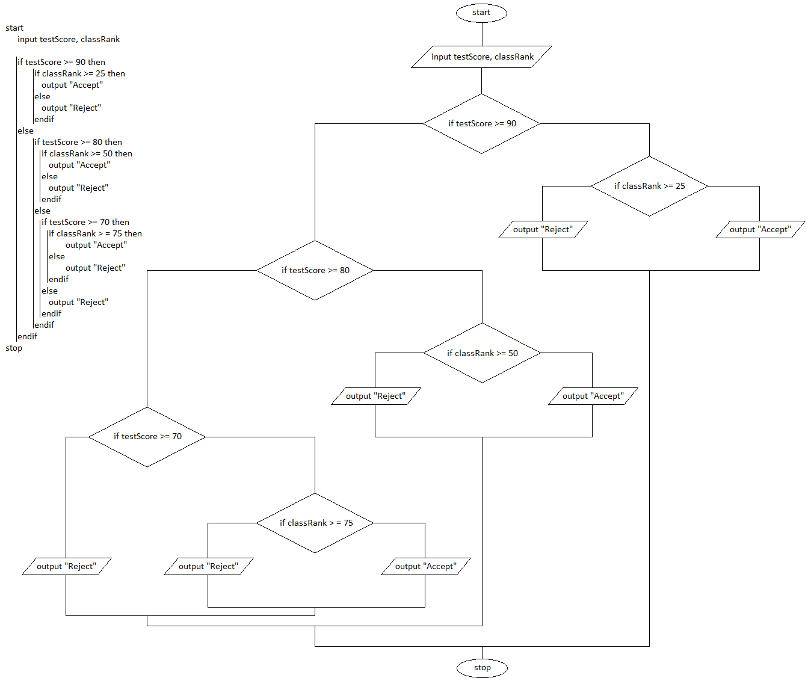

2. Lab 3-1 Program

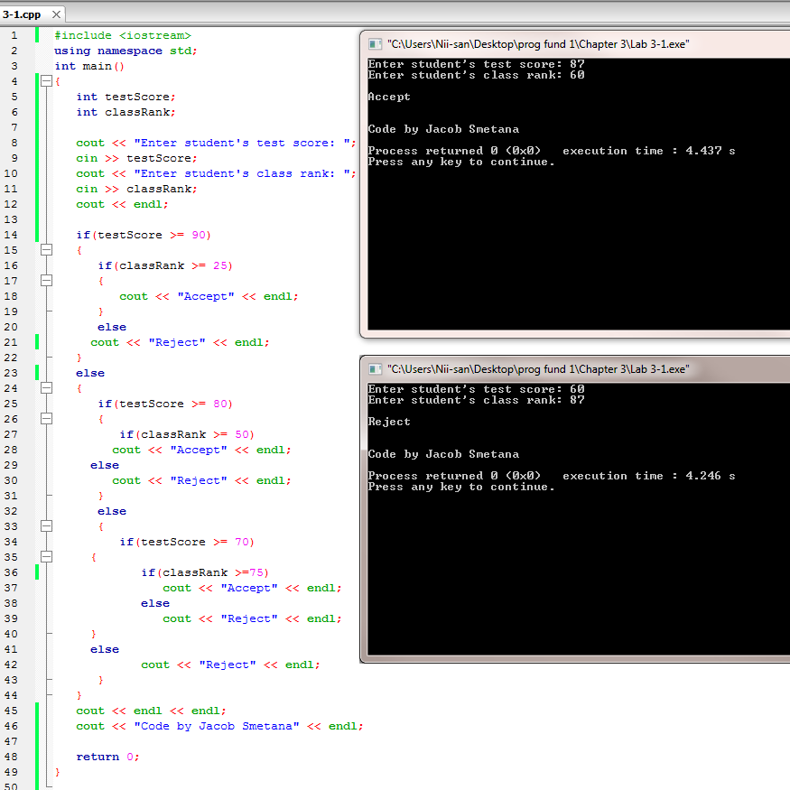

3. Payroll Report program

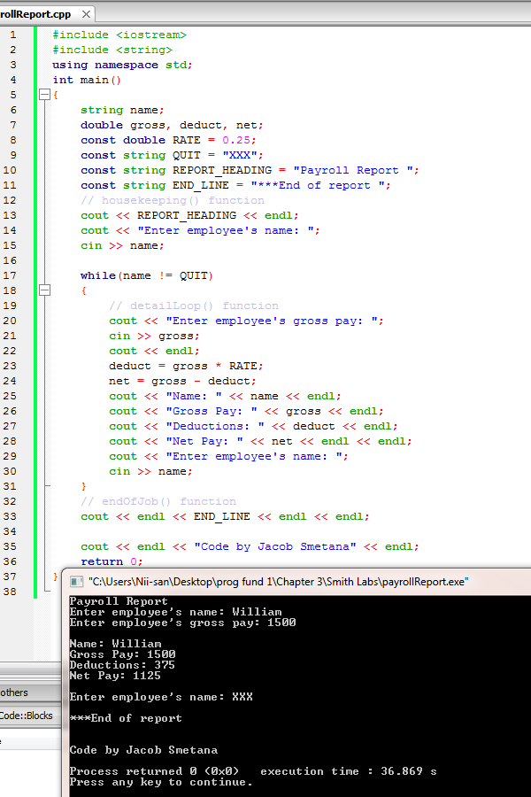

4. Lab 3-2 Flowchart and Pseudocode

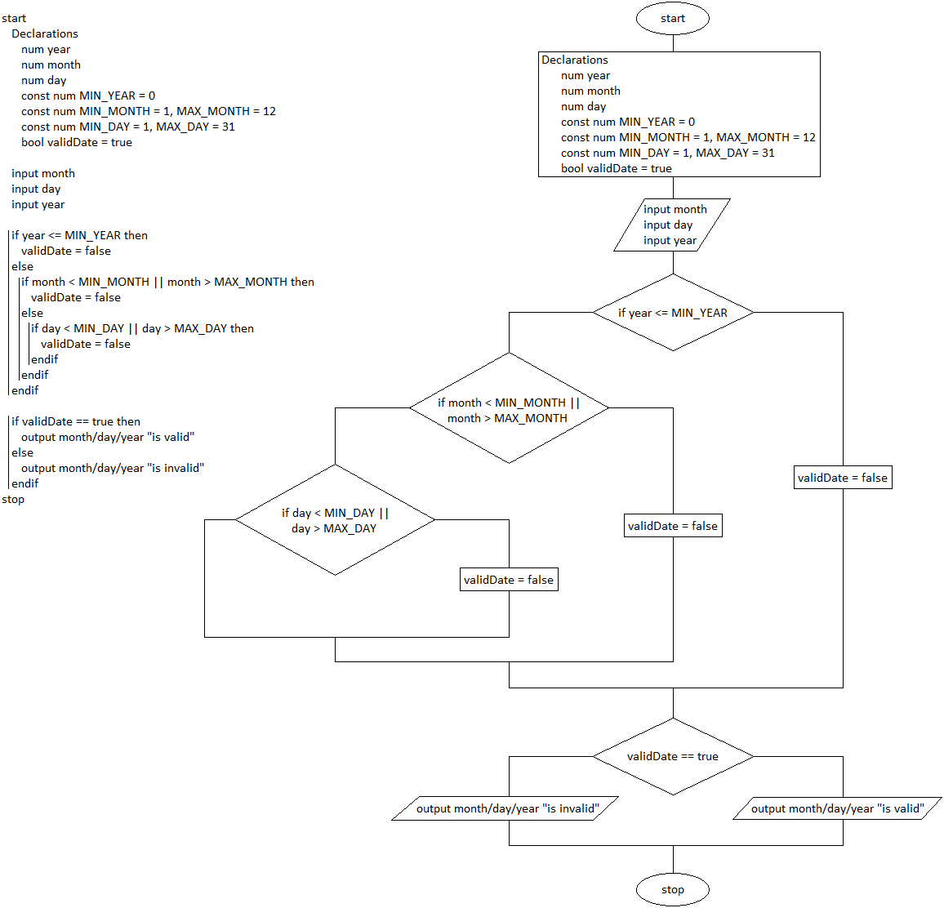

4. Lab 3-2 Program

